Shortcut for div class name

nav.navbar = <nav class=”navbar”></nav>

(The <**nav**> tag defines a set of navigation links. Notice that NOT all links of a document should be inside a <**nav**> element)

.visible = <div class=” visible”></div>

.div = <div class=” div”></div>

Step 1

The <ul> tag defines an unordered (bulleted) list.

Use the <ul> tag together with the [<li>](https://www.w3schools.com/tags/tag_li.asp) tag to create unordered lists.

* 1
* 2
* 3

The <a> tag defines a hyperlink, which is used to link from one page to another.

The most important attribute of the <a> element is the href attribute, which indicates the link's destination.

<nav class="navbar"> ------------HTML-------------

        <ul class="nav-list">

            <div class="logo"><img src="img.png" alt="logo" ></div>

            <li><a href="#home">Home</a></li>

            <li><a href="#about">About</a></li>

            <li><a href="#services">Services</a></li>

            <li><a href="#contact">Contact Us</a></li>

        </ul>

    </nav>

  <div class="rightNav">

    <input type="text" name="search">

    <button class="btn btn-sm"></button>

  </div>

Setting up Responsive Website

For medium screen : nav list = 70%, Right nav = 30% [screen size 75% 1192 x 457]

For short screen : as the screen size decreases we give media queries

[screen size 75% 892 x 457]

@media only screen and (max-width:1140px)

nav-list {flex-direction:column;}

nav-bar {flex-direction:column;}

rightNav{text-align:center;}

908 X 457

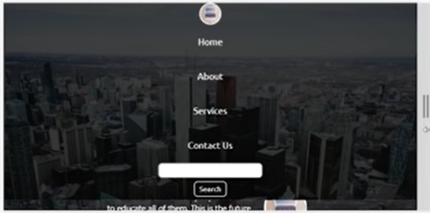

#search {width:100%} so that search box increases accordingly along with screensize



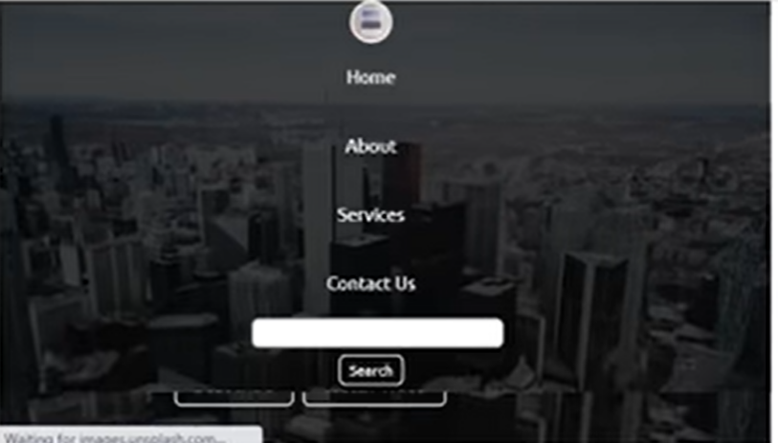

@media only screen and (max-width:1140px)

nav-list {flex-direction:column;}

nav-bar {flex-direction:column;}

rightNav{text-align:center;}

#search {width:100%}

Make burger display none (on increasing screensize it is mixing with search bar)

.burger{display:block;} whenever we increase size of screen hamburger disappears and whever shortened it appears.

h-resp{height:72px} add to navbar background class

(by default navbar height should be h-nav-resp,whenever we increase screen size navbar cont appear)

Next create v-resp {opacity:0}; add to nav-list & rightNav

Both nav-list,right-nav (home about etc…. & search gets disappeared as opacity:0)

javascript event listener

when click on hamburger class navbar background height should increase so that box-main content goes down.

Add script file inside body bottom of code.

Create resp.js and add event listener accordingly



After removing h-nav-resp from navbar , v-class is present opacity applied so navbar content is not visible

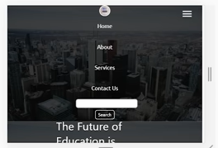

After removing v-class-resp & h-nav-resp from nav-list & rightNav

Ht is not applied and opacity is removed so navbar cont appears



With both classes h-nav-resp & v-class-resp

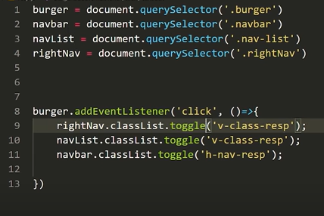

Defining classes in js

On click of burger

Toggle (opacity:0 for search)

Toggle (opacity:0 for home,about…)

Toggle (height:72px for both search & home,about….)

Create resp.js file as above

After event listener has applied successfully

We kept a transition and for that to settle we gave ht to navbar inside mediaquery

Checking responsivity for screen size 740 X 654 62%

In box-main (the future of education content is present) to handle that

Flex-direction : col reverse (so that img comes first)

Max-width:100%



 Section {flex-direction : col reverse;}

Problem of overlapping images to handle that

Sections ht is hardcoded so img’s are not able to occupy space

Remove ht from section.